**Assignment 5: Auto-Tagging EC2 Instances on Launch Using AWS Lambda and Boto3**

**Objective**: Learn to automate the tagging of EC2 instances as soon as they are launched, ensuring better resource tracking and management.

**Task**: Automatically tag any newly launched EC2 instance with the current date and a custom tag.

1. **EC2 Setup**: Ensure you have the capability to launch EC2 instances.
2. **Lambda IAM Role:**

- In the IAM dashboard, create a new role for Lambda.

- Attach the `AmazonEC2FullAccess` policy to this role.

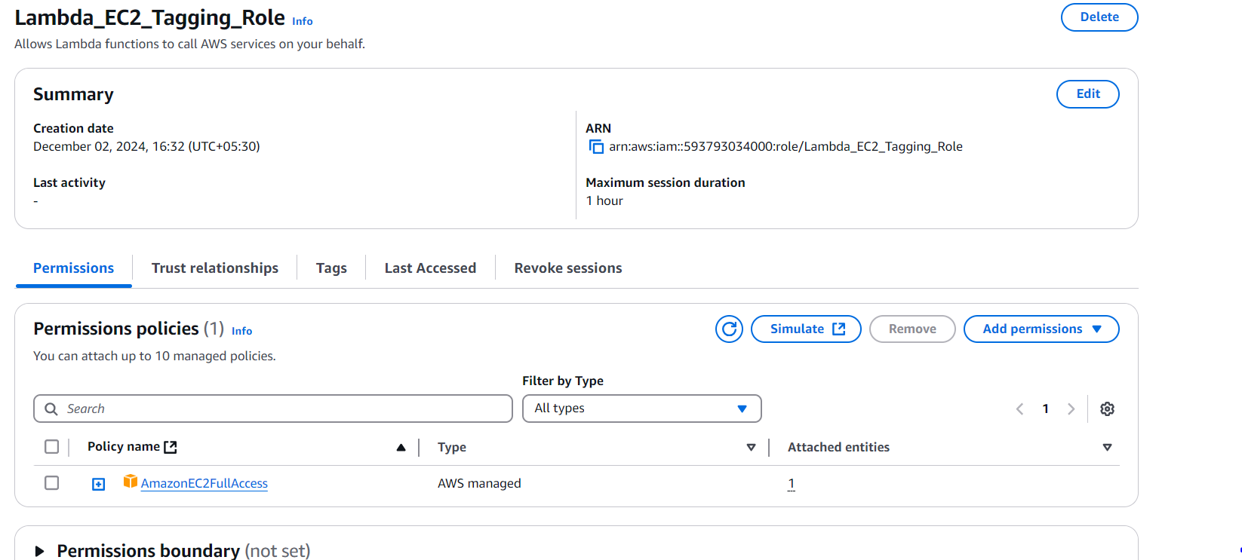

1. **Lambda Function:**

- Navigate to the Lambda dashboard and create a new function.

- Choose Python 3.x as the runtime.

- Assign the IAM role created in the previous step.

- Write the Boto3 Python script to:

1. Initialize a boto3 EC2 client.

2. Retrieve the instance ID from the event.

3. Tag the new instance with the current date and another tag of your choice.

4. Print a confirmation message for logging purposes.

***- Lambda function created and above role attached to it***

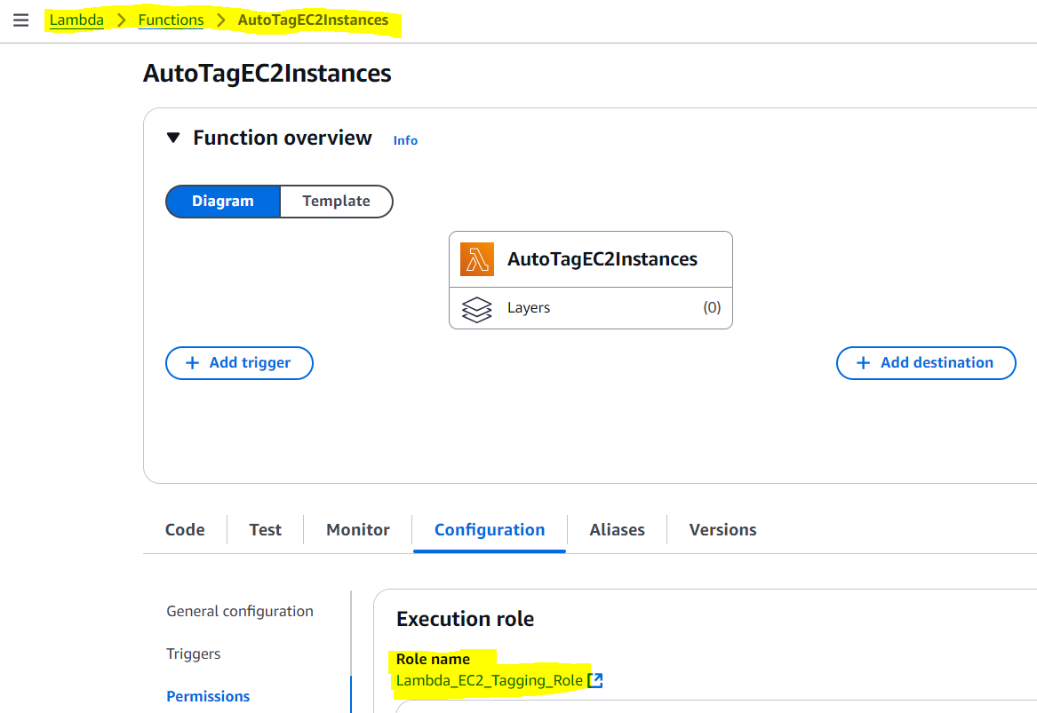

* ***Changed the configuration to run the lambda function till 1 minutes so that it will not through timeout exception at run time.***

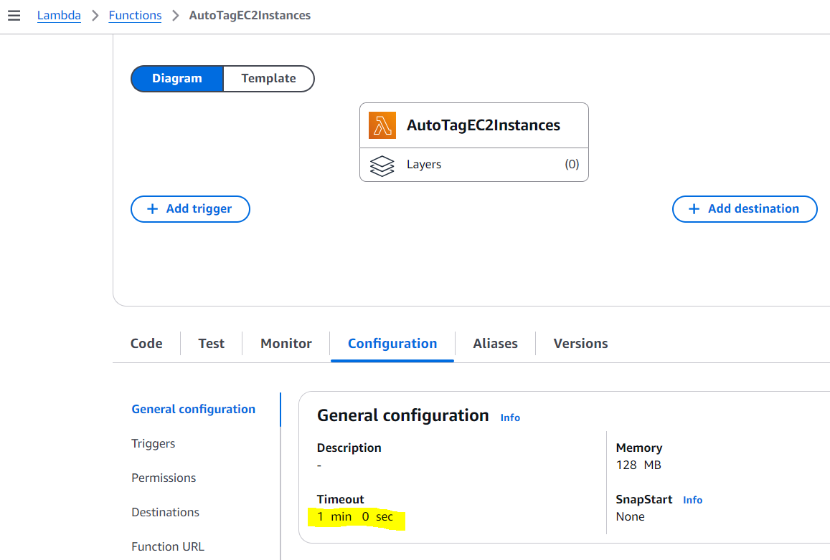

* ***Code Deployed to the lambda function***

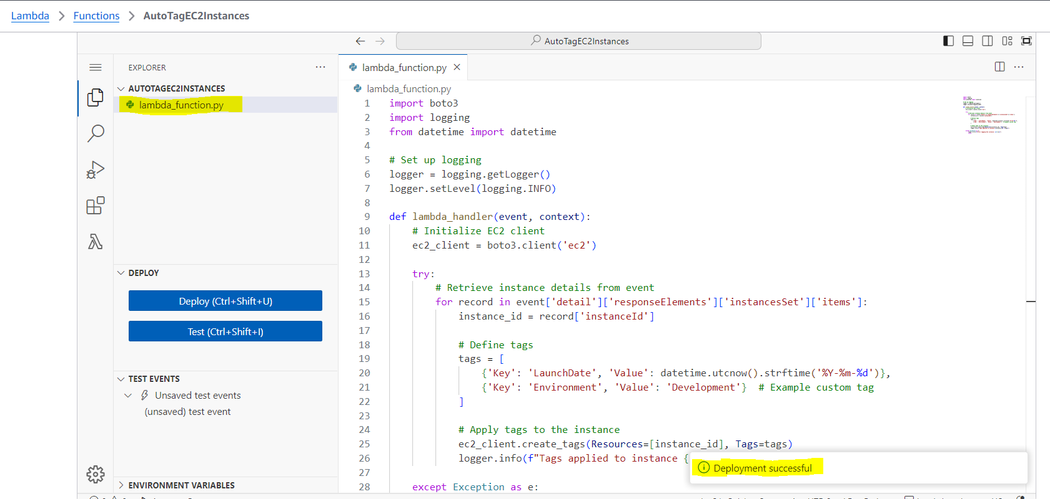

1. **CloudWatch Events:**

- Set up a CloudWatch Event Rule to trigger the EC2 instance launch event.

- Attach the Lambda function as the target.

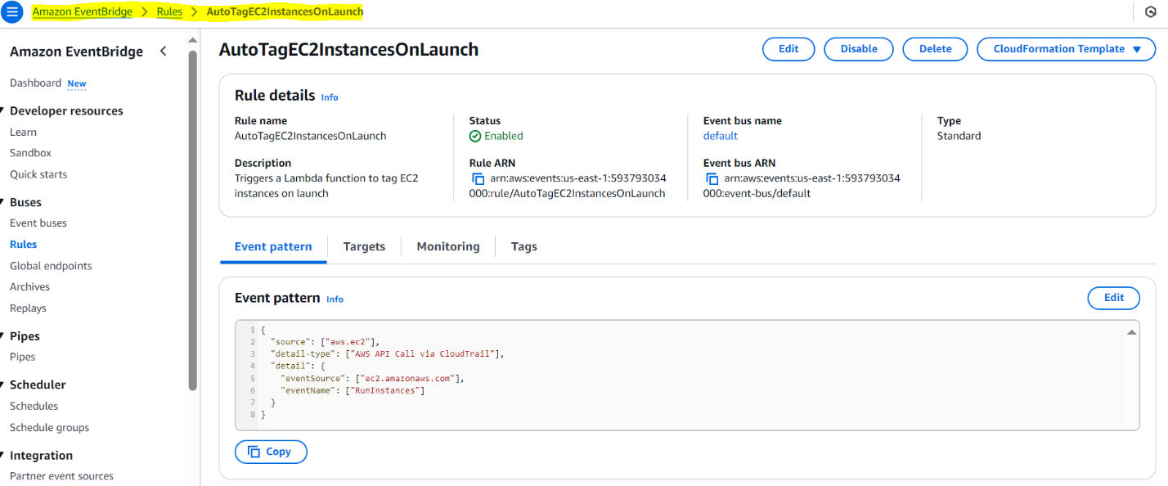

1. **Testing:**

- Launch a new EC2 instance.

- After a short delay, confirm that the instance is automatically tagged as specified.

